Prepared by Tattenhall and District Parish Council for Pre-Submission consultation under the Neighbourhood Planning (General) Regulations 2012 (as amended)
7 May 2024
Contents
1. Introduction and Background 2
2. Structure of the Plan 4
3. The Neighbourhood Plan Vision for Tattenhall 4
4. Objectives 5
5. Sustainable Development for the Whole Community 5
6. Strategy 6
7. Five Year Review 6
8. Neighbourhood Plan Policies 8
POLICY 1 Housing Growth 11
POLICY 2 Local Character 13
POLICY 3 The Local Economy 14
POLICY 4 Local Facilities 16
POLICY 5 Transport and Communication 17
POLICY 6 Landscape and Environment 19
10. Plan Delivery and Implementation 20
11. Appendix A: Views and Vistas 21
12. Appendix B - Local Green Spaces 24

Review for Consultation
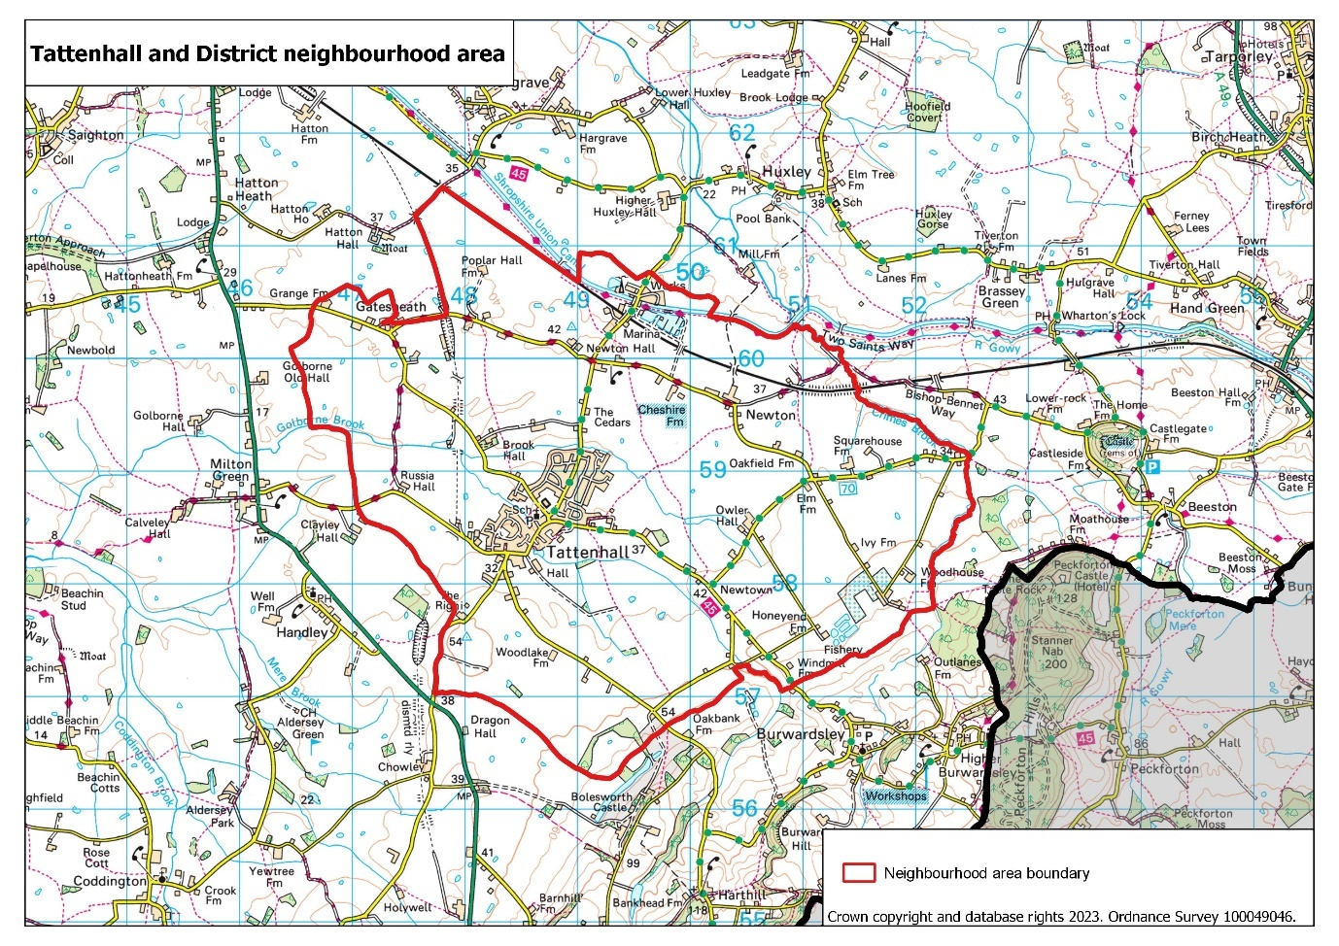

Introduction and Background
The Neighbourhood Development Plan aims to make Tattenhall and District an even better place to live and work, now and for future generations. The plan covers the period 2010 to 2030, the same as the Cheshire West and Chester (CWaC) Local Plan and this is the first 5-year review.
The Neighbourhood Plan process enables communities to influence the type, quality and location of development, ensuring that change brings local benefit.
The community of Tattenhall has a strong history of local decision making. In 2006 the Tattenhall Parish Plan was ratified by the Parish Council and set out a vision and action plan for how the District wished to see itself develop. Subsequently, the community prepared the Tattenhall Village Design Statement, which was adopted as a Supplementary Planning Document by Chester City Council in 2009.
Neighbourhood Planning provides an opportunity for the community to have a real say over local decision making, to achieve its long-standing goals through the planning system and address the challenges and opportunities facing the future vitality of the Parish.
The Neighbourhood Plan is based on extensive research and influenced by robust engagement with the local community. The Made Plan carries significant weight in the determination of planning applications.
Location and History
The Parish of Tattenhall is situated in south-west Cheshire, 13 Km (8 miles) south east of the City of Chester and includes the village of Tattenhall and the two smaller settlements of Gatesheath and Newton-by-Tattenhall. The landscape of the parish is characterised by the Cheshire Plain, a gently rolling pastoral landscape separating the Sandstone Ridge from the Clwydian range of hills in North Wales. The parish lies on the watershed separating two major river systems – the Dee and the Mersey. Of the five water courses that flow through the parish, the Keys Brook, Mill Brook and Golborne Brook flow into the Dee, and in the north of the parish Crimes Brook joins the River Gowy which flows into the Mersey near Ellesmere Port.
The history of Tattenhall dates back to post Roman times. The village was already of some economic importance in AD 991. During the fifteenth and sixteenth centuries Tattenhall was a quiet, self-sustained village, growing its own food and weaving its own cloth. The building of the Chester Canal (now the Shropshire Union Canal) during the 1770s improved transport of goods, including cheese and other dairy products to all parts of the country and, as a result, small industries started to locate in the area. These developments were to result in the doubling of the population by the middle of the nineteenth century.
During this time, Tattenhall sustained its prosperity, developing its economy and infrastructure. The London and North Western Railway (LNWR) reached the parish by the middle of the century. The railway, like the canal before it, opened up new and more distant markets and attracted light industries to the village and other parts of the parish.
The railway line between Chester and Crewe was opened in 1840 and a railway station was built at Newton-by-Tattenhall. In 1872 a branch off this line was opened to Whitchurch and another station was opened at Frog Lane, Tattenhall. Tattenhall became an attractive place in which to live and work, evidenced today by the substantial Victorian buildings both in the village and on the surrounding farmsteads.
By the mid nineteenth century the improved transport facilities saw the development of a thriving industrial centre adjacent to the canal and railway at Newton-by-Tattenhall. In 1860 extensive works on the opposite side of the road saw the manufacture of bricks and field drainpipes, a practice that continued until 1975 when the site was sold. Such industries relied heavily on the canal and the railway for both the import of raw materials and for the export of finished products throughout north-west England and North Wales.
The second half of the 20th century was marked by successive periods of housing development, as new estates were built between the 1960s and the 1980s to the north and west of the village centre. More recently, smaller developments have occurred within the heart of the village mainly on previously developed sites, as well as a large development for the retirement community just on the outskirts of the village.
Whilst agriculture remains a significant feature of the local economy, new office building has occurred in the centre of the village, together with refurbishment of farm buildings throughout the Parish to meet new uses. These developments, promoted by the Bolesworth Estate, have contributed to a dynamic economy in which approximately 300 businesses operate within a three-mile radius of the village centre (Tattenhall Business Alliance, 2023).
Recent years have seen the development of tourism related activity in Newton-by-Tattenhall with the growth of the Cheshire Ice Cream Farm and the opening in 2009 of the 300 berth Tattenhall Marina adjacent to the Shropshire Union Canal. Bolesworth Events including International Horse Show and Christmas Light shows, are now regularly held at Bolesworth Castle, leading to large numbers of visitors many of whom need accommodation outside the events. There is now a thriving new industry of ‘Glamping’, part of the farm businesses diversification.
How the Original Neighbourhood Plan was prepared
The Tattenhall Neighbourhood Plan was prepared by residents and members of Tattenhall and District Parish Council working as part of a Neighbourhood Planning Steering Group with support from Cheshire Community Action, Rural Innovation, CWaC and IBI Taylor Young. The process involved a number of key steps:
Designation and Raising Awareness
In March 2011 Tattenhall and District was designated as a second wave Neighbourhood Planning Frontrunner. A steering group was formed to discuss the creation and scope of the neighbourhood plan process. During the summer of 2011 the steering group attended several village events informing residents of the forthcoming neighbourhood plan.
Consultation and Evidence Gathering
During September and October 2011 over 100 people attended five public open meetings held across the Parish. These were asked what they liked and disliked about the Parish, how they would want to see it evolve and the benefits new development should bring to the community. To ensure the consultation process was as inclusive as possible the steering group also sought the views of Tattenhall primary school pupils, local businesses and organised a well-attended ‘rave’ for teenagers – a requirement of entry to this event being that the young people filled in the NP questionnaire.
The Steering Group mobilised themselves to begin the process of gathering evidence to support the Plan. This included reviewing evidence reports prepared by CWaC, preparing a neighbourhood profile using key national and local statistics and producing a Sustainability Appraisal Scoping Report, which contains a broad range of statistics and information that helped to identify issues for the Parish. This information is provided in separate supporting documents.
Vision and Objectives Development
Analysing the findings of the autumn 2011 consultation exercises and local evidence, the Steering Group drafted a Vision and Objectives document for the Neighbourhood Plan. The findings were grouped into seven themes, with each of these themes identifying the local issues for the topic and the proposed actions to address them. The Vision and Objectives document was sent to every household in the Parish as part of a four-week consultation during June 2012.
Draft Plan Creation
Throughout July to November 2012 the Vision and Objectives proposals, responses to community engagement exercises and local evidence were used to develop the draft Neighbourhood Plan. Consultants IBI Taylor Young were appointed to support this process. The Plan was sent out to every household in the Parish and neighbouring parish councils during a six-week public consultation. A Sustainability Appraisal of the Plan was undertaken.
Submission, Examination and Making of the final Plan.
All the comments from the six-week statutory local consultation exercise were analysed and fed into this document, the proposed Neighbourhood Plan. As a result of this consultation significant changes were made to the form and structure. These included consolidation of policies, improved layout and honing the document for end users. The Plan and its supporting documents were then submitted to CWaC for a six-week publicity period. The Plan was subject to independent examination in August 2013 and in September 2013 CWaC resolved to proceed to referendum. The community support for the draft policies was confirmed at the referendum. The local community gave a ringing endorsement to the plan, with an overwhelming ‘yes’ vote (905 votes to 38). The ballot produced a convincing 51.8% turnout of the 1,822 eligible voters. The examination of the Plan was the subject of a judicial review in March 2014 when challenged by developers but the appeal was dismissed and the Plan was Made in June 2014.

Structure of the Plan
The Neighbourhood Plan sets out:
- The Vision and Objectives for the future of Tattenhall and District
- The Neighbourhood Plan Strategy – Sustainable Development for the Whole Community – setting out the broader aims of the Plan’s approach.
- The Neighbourhood Plan Policies – Providing the local policy framework for managing new development so that it contributes to the vision, aims and strategy for the District.

The Neighbourhood Plan Vision for Tattenhall
As detailed in the Tattenhall Parish Plan (2006) and Tattenhall Village Design Statement (2009) the community wants Tattenhall to continue to thrive as a vibrant and distinctive village, to continue to respect and reflect the views of its community, to evolve and expand whilst retaining its unique and distinctive character, and to provide an outstanding quality of life for current and future generations of residents.
The Parish Council will do this by:
- Encouraging a thriving and prosperous community that delivers a high quality of life for all its residents.
- Promoting a distinctive and flourishing local economy that exhibits vitality and dynamism.
- Supporting measured, proportionate, timely and sustainable development to meet local requirement.
- Endorsing policies that have a positive effect on the environment, including those that remove or minimise flood risk, mitigate climate change and reduce our carbon footprint.
- Maintaining the high-quality natural environment with its protected wildlife interests.

Objectives
- Delivery of a housing growth strategy tailored to the needs and context of Tattenhall.
- Sensitive, sustainable development of good design which protects and enriches the landscape and built setting.
- Sustaining and improving excellent local facilities for existing and new residents.
- Strengthening and supporting economic activity.
- Seek on-going improvements to transport, to utility infrastructure and to digital connectivity.
- Prioritise local distinctiveness in every element of change and growth.
- Protect greenspace, the landscape and support nature conservation.
- Involve local people in an ongoing basis in the process of plan-making, monitoring and delivery of development.

Sustainable Development for the Whole Community
Sustainable development is about positive growth – making economic, environmental and social progress for this and future generations. These three dimensions constitute what is sustainable in planning terms.
Economic – contributing to building a strong, responsive and competitive economy
Social – supporting strong, vibrant and healthy communities
Environmental – contributing to protecting and enhancing our natural, built and historic environment
To achieve this, a thoughtful and innovative approach is required, which works more positively; with residents, landowners and developers taking a continuing interest in the future of the village.
This is the approach adopted in the Plan and on the basis of this the Parish will look to engage positively with the statutory planning process to guide future development.
People living in Tattenhall appreciate the special qualities the village possesses. It is a great place to live and in accommodating housing growth it will be vital that the qualities which make Tattenhall so successful are protected. Current residents accept that more people will want to come and live in Tattenhall and this is important to any thriving and evolving community.
This plan is not anti-development and the community understands the need to accommodate housing growth. But there is great concern that new development in Tattenhall could erode the very qualities that make the village special if it is not carefully managed in terms of its scale and design. This next layer of growth for the village must create developments of quality which contribute to the character of the village and which provide local benefit. It must be more than an exercise in meeting housing supply ‘numbers’ by the addition of characterless estates on the rural fringes of the village more typical of suburban developments. The objective, therefore, is to enable the provision of a choice of new homes to meet the needs of all sections of the community in a manner which respects the character of the village and wider parish.

Strategy
The heart of the village will be prioritised as a thriving centre for local shops services and community infrastructure. Sustaining local businesses and improving local facilities is a key plan priority. Local community facilities will be supported.
Housing growth is to be accommodated in a sensitive way and the strategy for housing growth is explained later in this document (See Policy 1). This is primarily based on modest scale developments within and on the edge of Tattenhall village but also enabling smaller scale development across the Parish. Future growth based on large scale, inappropriate development along existing village boundaries will not be supported by the community.
A number of small scale dispersed developments can be accommodated throughout the parish and could provide new affordable housing, opportunities to new and existing residents and meet the housing numbers and deadlines defined by Cheshire West and Chester Council Emerging Local Plan.
The continuing care retirement community development helps to diversify the housing offer in Tattenhall and the local area.
Important green spaces are to be protected as are strategic views within the Parish and into and out of the village of Tattenhall (Important views are listed at Appendix A). Green wildlife corridors are promoted along Keys Brook and Mill Brook through, and around Tattenhall.
The Plan is also positive about new employment development of an appropriate scale, in the village of Tattenhall and at the hamlets of Gatesheath and Newton-by-Tattenhall.
Improved walking and cycling connections are promoted, as an early action, from the hamlets to Tattenhall via new footways. As a longer term aspiration the creation of a new railway station is highlighted as an opportunity to provide a sustainable link to Crewe, Chester and beyond.

Five Year Review
Designated Area review
The Parish boundary was changed by CWaC in 2018 and consequently the Neighbourhood Plan designated area and Parish area were no longer consistent. The Parish Council proposed a revised Tattenhall and District Neighbourhood Area that follows the same boundary covered by Tattenhall and District Parish Council. It includes the settlements of Tattenhall, Newton, Tattenhall Marina, Newtown and Gatesheath. The Neighbourhood Area is located within the Tattenhall ward. The revised boundary only results in a change to the north, with three small parcels of land now included around Gatesheath, Poplar Hall Farm and Crow’s Nest Bridge and now excludes land to the north of Newton-By-Tattenhall. Only a very small number of the people /properties are impacted by the change as the new area designation is in open countryside. All 20 properties received notification of the proposed changes in advance.
An application for the designation of the revised Tattenhall and District Neighbourhood Area was made under Regulation 5 of The Neighbourhood Planning (General) Regulations 2012 (as amended) (the Regulations).
The application was approved by CWaC on 12 April 2023. The reasons for this decision were that the Tattenhall and District Neighbourhood Development Plan Area is considered appropriate because:
- Although a previous application has been made for Neighbourhood Areas covering part of the area this is related to a review of the Neighbourhood Plan with the new area superseding the existing when the review plan is made.
- Tattenhall and District Parish Council is the relevant body to undertake Neighbourhood Planning.
- The Neighbourhood Plan Area follows the boundary of the area covered by Tattenhall and District Parish Council and it is appropriate for development in this area to be guided by a Neighbourhood Plan.

Policy performance against stated Objectives
Using the 8 stated objectives, the review group identified a number of indicators against which the performance of the Plan and its policies could be measured.
In addition, CWaC Local Plan (Part 2) monitoring framework contains its own indicators, many of which are relevant to Tattenhall and were used.
The main sources of data were planning applications from the CWaC website using the search tool and the CWaC annual monitoring reports.
The Neighbourhood Plan Monitoring Report was compiled and used to inform recommended changes to the Plan policies. In summary, the conclusions and recommendations are:
Objective 1 has been partially met. The Plan has successfully delivered small scale housing development of 30 or fewer as set out in Policy 1, most notably in April 2017 when appeals were dismissed for proposed construction of 329 houses on three sites. The Plan has enabled small-scale developments so that the target of at least 250 dwellings by 2030 set in the Local Plan (Part 1) STRAT 8 has already been surpassed. Affordable housing has fallen short of the 35% target of the Plan.
Recommendation: Amend Policy 1 to be in general conformity with the Local plan Policy SOC1 and to facilitate meeting identified local affordable housing need so that it remains an affordable dwelling for local people in perpetuity.
Objective 2 is being supported by the plan.
Recommendation: No change necessary to existing policy.
Objective 3 is being supported by the Plan.
Recommendation: No change necessary to existing policy.
Objective 4 Little evidence for objective being met by policies.
Recommendation: Consideration should be given to ways to strengthen Policy 3 to make the policies ‘encouraging’ rather than ‘supportive’.
Objective 5 No evidence that the Objective has been advanced by the plan policies. The related policies remain aspirational.
Recommendation: Consideration should be given for policies to support better cycling provision, such as cycle racks in the village centre and improved cycle ways between Newton, Gatesheath and Tattenhall.
Objective 6 is being supported by the policies.
Recommendation: No change necessary to existing policy.
Objective 7 is supported by Plan policies, but climate change, green energy and carbon neutrality are omissions and not explicit in the Objective. The original Plan has partially met Objective 7 through the Village Design Statement.
Recommendation: Consider update to Village Design Statement to prevent progressive weakening due to being increasingly out-of-date. Consideration should be given to strengthen policies to prevent further loss of green space, re-provision of lost open space and support schemes to protect the environment including green-energy supply.
Objective 8 No evidence that the objective is being met.
Recommendation: Consideration should be given to a policy to require developers to have thorough and detailed discussions with the Parish Council before submitting planning applications and to keep the Council updated on the applications and developments progress.
Tattenhall Village Design Statement review
A review of the Village Design Statement (2009) was undertaken because of its age and also because, although an integral part of the original Neighbourhood Plan through Policy 2, there was evidence that the policies were not given enough weight during the planning process. The Ministry of Housing Communities & Local Government published in October 2019 the National Design Guide and subsequently in January 2021 the National Model Design Code. The Review Working Group recommended to replace the design statement with a design code. With the assistance of AECOM, commissioned by Locality (https://locality.org.uk/), the Tattenhall and District Design Code has been produced to be adopted and integrated with the reviewed Neighbourhood Plan replacing the Tattenhall Village Design Statement.

Neighbourhood Plan Policies
The following suite of policies has been developed to manage the future development of Tattenhall in order to achieve the vision, objectives and strategy of the Neighbourhood Plan. Decision makers and applicants must consider the policies as a whole when judging if a proposal would be acceptable.
To reflect the results of the consultation events undertaken during the Plan’s preparation and evidence of local issues and characteristics the policies are separated into six themes – Housing, Local Character, Local Economy, Local Facilities, Transport and Communications and Landscape and Wildlife.
To aid interpretation, for decision makers and applicants each policy is accompanied by supporting text setting out the context for the theme and the local community’s views on that subject. All policies have been framed in the context of the National Planning Policy Framework and the adopted Local Plan for CWaC.
Whilst the Neighbourhood Plan is first and foremost a land-use document a number of issues falling outside of the planning system’s remit were identified by the local community during consultation events. Alongside its core policies the Plan therefore includes a number of aspirations to encourage interventions by wider stakeholders. These are included within each topic where relevant.
Housing Growth
Justification and Evidence
There are currently 1150 dwellings in the parish of Tattenhall. Of these, 941 are located in the village whilst the remainder are spread around the Parish including the smaller settlements of Gatesheath and Newton-by-Tattenhall (2021 Census).
The adopted CWaC Local Plan (Part One) set the agenda for housing numbers and growth within Tattenhall as a Key Service Centre. Tattenhall is looking to plan positively to meet its identified local housing requirement and will respond to the supply of these new homes.
The best villages have developed through incremental growth that harmonises with the existing character of their setting and buildings. It is essential that this continues to be the case in Tattenhall. The supply of new homes in the village and wider parish must be realised in accordance with the distinctive features, scale and grain of the local area. Housing sites must be carefully considered and will only be acceptable where they reflect these principles and are consistent with the Neighbourhood Plan taken as a whole.
Delivering a wide choice of high-quality homes is essential to support sustainable, mixed and inclusive communities. In Tattenhall this will underpin a well-balanced population that is vital to the on-going viability of local services and prosperity of the Parish, particularly in light of the community’s increasingly ageing population. Evidence from the CWaC Strategic Housing Market Assessment indicates demand for a range of property sizes and types in the Tattenhall area. Housing developments must therefore provide a mixture of housing to meet the needs of the community.
The supporting text of the original Neighbourhood plan stipulated a requirement to provide 35% affordable units on site, with a provision of both intermediate and affordable rent. This requirement preceded the adoption of the Local Plan (Part One), in which policy SOC1 states that, for developments of 3 or more dwellings, up to a target of 30% of units should be affordable.
Affordability, however, remains a key housing issue for Tattenhall and there is a compelling case to meet local targets for affordable housing provision, with average house prices too high for those on average incomes. In order to understand fully the housing issues in Tattenhall, a Housing Needs Report for Tattenhall and District (Parish) was undertaken in 2018, funded by CWaC and prepared by Cheshire Community Action. This report indicated that whilst Tattenhall had performed well in terms of dwelling completions during the plan period, the area had fallen short of achieving 30% affordable housing.
In 2022, of the 269 units in Tattenhall that have received planning permission that requires an element of affordable housing, only 70 are affordable – a figure of 22%. In the rural parts of the Parish this figure falls to 16% of units, with 11 out of 67 applicable dwellings being affordable. (See Appendix 2)
The Housing Needs Report was updated in 2023, again prepared by Cheshire Community Action. The updated Housing Needs Report detailed that in 2022 the affordability ratio in Tattenhall Ward was 10.5 for median prices to median income, with lower quartile prices to lower quartile income 10.13 i.e., house prices are 10.5 times the annual average Tattenhall Ward salary. This is higher than the CWaC average of 6.83. Median and lower quartile incomes are higher in Tattenhall Ward than those in the borough as a whole (£38 106 and £25 821 as compared to £33 661 and £24 468). However, median dwelling prices in Tattenhall Ward from 2022 averaged £170 000 above the borough average and lower quartile dwelling prices in Tattenhall Ward averaged £96 500 above the borough average. To put this into perspective, to afford a lower quartile priced dwelling in Tattenhall Ward at a mortgage offer of 4.5 times salary and with a 10% deposit, an income of £52,300 would be needed which is £26,479 more than (and over double) the lower quartile income of £25,821. These figures clearly demonstrate how unaffordable local house prices are in relation to income. Within the Ward, Tattenhall is the only Key Service Centre which the Local Plan considers suitable for sustainable new development.
House prices and income figures 2022:
2022 | Tattenhall Ward | CWaC
Median Price | £400,000 | £230,000
Median Income | £38,106 | £33,661
Affordability ratio | 10.50 | 6.83
LQ House Price | £261,500 | £165,000
LQ income | £25,821 | £24,468
Affordability ratio | 10.13 | 6.74

The 2023 Housing Needs Report shows that the gap between income and house prices has increased in Tattenhall Ward since the previous affordability assessment in 2011, indicating that new developments would benefit from affordable home ownership tenures discounted to align with local income levels.
The overall annual shortfall of affordable rented housing is documented in the table below:
Property Type | Need for affordable / social rent  from the housing register  (Households based in Tattenhall Ward Dec 2022) | Estimated supply of affordable /social rent  from planning approvals | Estimated supply from re-lets of existing affordable stock  (annual average) | Estimated annual shortfall (-) / surplus (+)  of affordable rented housing
1 Bed | 16 | 4 | 4 | 8
2 Bed | 8 |  | 5 | 3
3 Bed | 5 |  | 4 | 1
4+ Bed |  |  | 0 | 0
Total | 29 | 4 | 13 | 12

The housing register need for affordable rented accommodation (based on data from Dec 2022) for people with a local connection to the Tattenhall Ward (therefore eligible for affordable housing in the neighbourhood area) is: 29 households – made up of 55% 1 bed need, 28% 2 bed need, and 17% 3 bed need.
The estimated annual supply of affordable rent from planning approvals (based on CWaC housing supply forecasts 2021-22) is four x 1 bed units.
The estimated annual supply of affordable rent units from turnover of existing stock is thirteen units per year on average, with 31% 1 bed, 39% 2 bed and 31% 3 bed becoming available.
The estimated annual shortfall of affordable rented housing is therefore twelve units per year – 67% 1 bed, 25% 2 bed and 8% 3 bed.
The shortage of availability of affordable housing, coupled with the growing discrepancy between average earnings and house prices, make it considered to be imperative that new housing provides at least 30% affordable units in the Neighbourhood Plan area, and that any off-site contributions contribute to the provision of affordable housing within the parish. This will help to address these issues and ensure that Tattenhall parish remains a vibrant, sustainable and inclusive community where people can afford to live and work.
Tattenhall has a significantly higher proportion of detached housing than CWaC (40.8% as compared to 29.6%) and a significantly lower proportion of terraces (15.4% compared to 21.7%) and flats (7.4% compared to 12.2%). It also currently has a significantly lower proportion of 1-2 bed bungalows, 1-2 bed flats and 1-2 bed terraces. The 2023 Housing Needs Report highlights that the growing gap between income and house prices indicates that the Neighbourhood Plan area would benefit from affordable home ownership tenures discounted to align with local income levels including discount sale and shared ownership. Based on an up-to-date analysis of the housing register, the estimated annual shortfall of affordable rented housing is 12 units per year – 67% 1 bed, 25% 2 bed and 8% 3 bed. Additionally, the population continues to age, with over 65s increasing from 24% of the population to 30% from 2011-2021. Housing that caters for older people therefore remains an important part of the housing mix required in the Neighbourhood Plan, including, for example, a good range of downsizing options, along with the provision of Lifetime Homes, bungalows and Extra Care Housing.
The community recognises that housing development can sometimes bring wider benefits, such as the redevelopment of brownfield sites, securing the on-going use of a building and providing much needed affordable homes. Such proposals will be supported in accordance with this policy and the Neighbourhood Plan.
Community Feedback
Consultation on the original Neighbourhood Plan revealed the following key issues in relation to this topic that the policy seeks to address:
- Respect the current village character 92% agreed
- Add value and vitality to the community 91% agreed
- Add housing choice and meet local needs 86% agreed
- Comply with the Village Design Statement 88% agreed
- Be limited to 25 new homes over the next 5 years 28% agreed
- Be limited to 26-50 new homes over the next 5 years 52% agreed
- Be limited to 51-100 new homes over the next 5 years 19% agreed
- Use brownfield sites as a priority 94% agreed

POLICY 1 Housing Growth
To enable managed housing growth in the Parish:
- Proposals involving up to and not exceeding 30 homes on any one site will be allowed within the settlement boundary of Tattenhall, to meet the housing requirements established in the CWaC Local Plan. Proposals outside the settlement boundary of Tattenhall must comply with Local Plan policies STRAT9, SOC2 and DM24.
Housing proposals of 3 or more dwellings must:
- Provide a mix of homes taking into account objectively identified housing needs, and
- Include an element of affordable housing as specified in the Local Plan. The affordable housing will be subject to a S106 Legal Agreement ensuring that it remains an affordable dwelling for local people in perpetuity.
- Proposals which have capacity of three or more dwellings or comprise an area of 0.1 hectares or more, must include at least 30% affordable housing and comply with Local Plan (Part One) SOC1. Affordable housing provision will be sought on site unless there are exceptional circumstances which can be demonstrated to justify off-site contributions. Any off-site contributions must go towards the provision of affordable housing in Tattenhall Neighbourhood Plan Area in the first instance.

Local Character
Justification and Evidence
The landscape surrounding Tattenhall retains a significant historic character. Areas bordering the north, north-west and north-east of the village are classified as ‘Ancient Field Systems’ or ‘Medieval Townfields’ by the Cheshire Historic Landscape Characterisation. These areas contribute to local distinctiveness and the retention of their character is a key element in achieving sustainable development.
Whilst agriculture remains the principal land use in Tattenhall, the character of the local landscape is also defined by its buildings, several of which have been listed for their special architectural or historic interest. Today the village of Tattenhall is one of the most attractive and least spoilt of the larger villages in south west Cheshire. Much of the village is now designated a Conservation Area and is well defined, radiating out from the centre. It is essential that these qualities are protected. The historic assets in the area are shown on the built historic environment designations map.
A significant amount of local work has taken place to identify the features that make Tattenhall unique. After comprehensive consultation, the community published the Tattenhall Village Design Statement in 2009 with recommendations based on a detailed understanding of the village’s landscape setting, its shape and grain and the style and nature of its buildings. Tattenhall Village Design Statement has been replaced by Tattenhall and District Neighbourhood Plan Design Code in compliance with the National Planning Policy Framework. The Tattenhall & District Design Code 2023 describes the distinctive surroundings and character of the district, based on clear guidance from the community that all new developments must follow to be successfully accommodated into the Parish. Standard designs will not be acceptable. Proposed developments must fully comply with the Design Code.
The successful and busy village centre is a very positive attribute of Tattenhall which inevitably and understandably results in the need for signage. Whilst ensuring that businesses are clearly visible, it is important that this is managed to avoid an unacceptable proliferation of signage that could undermine local amenity.
There has been concern locally about the loss of trees with amenity value within the village. Such trees contribute significantly to the attractiveness of the village and every effort should be made to retain them. All new development, as well as incorporating new tree planting and landscaping, schemes, should be designed to safeguard any existing significant trees including allowing sufficient distance between them and new buildings to avoid later pressure for their removal. Following the review, further protection of trees is sought by replacement of any lost trees at the ratio of 2 for 1. Strengthened wildlife and biodiversity protections are sought by additional policies to retain and protect ancient, veteran and mature trees, hedgerows, ponds, and areas of woodland as well securing and enhancing connectivity of wildlife corridors including the Mill Brook and Keysbrook wildlife Corridors.
Tattenhall should only receive the very best, attractive and sustainable development. Building for a Healthy Life, a government-backed industry standard for well-designed homes and neighbourhoods can help ensure that this is the case. Building for a Healthy Life sets out the criteria to assess the quality of a development scheme. Proposals coming forward in Tattenhall should be exemplary, ideally scoring twelve out of twelve greens when assessed against these criteria.
Tattenhall and the surrounding rural area experiences some of the highest rates of fuel poverty and energy consumption in the wider CWaC area, whilst a number of properties are still supplied by fuel oil as a result of being off the main energy supply network. It is essential that all communities take action in their local area wherever possible to tackle the national and global issue of climate change. In this context it is therefore essential that steps are taken to encourage developments that are more energy efficient and make use of opportunities to use green sources of energy wherever possible.
Community Feedback
Consultation on the original Neighbourhood Plan revealed the following key issues in relation to this topic that the policy seeks to address:
- Match the grain and quality of the Village Design Statement Character Zones 93% agreed
- Not spoil the views into and out of the village and parish 94% agreed
- Enhance the Character Zones as detailed in the Tattenhall Village Design Statement
90% agreed
- Be at a measured pace to enable infrastructure expansion 91% agreed
- Minimise impact on woodland, hedges, ponds, streams, verges and geological
features 96% agreed
- Ensure boundaries respect/reflect local tradition/ materials 93% agreed
- Include native Cheshire species in landscaping 92% agreed
- Minimise unnecessary tree felling 94% agreed

POLICY 2 Local Character
Development will be supported where it:
- Safeguards or enhances the local character and historic and natural assets of the surrounding area, and takes every opportunity, through design and materials, to reinforce local distinctiveness and a strong sense of place.
- Incorporates, wherever possible, locally distinctive features such as Cheshire railings and fingerposts.
- Does not erode, beyond the curtilage of existing residential property, the important, predominantly undeveloped gaps between the three settlements of Tattenhall, Newton-by-Tattenhall and Gatesheath.
- Can demonstrate full accordance with the Tattenhall and District Design Code (2022) or any updated version. This may include (but is not limited to) construction, design, energy efficiency and landscaping.
- Respects local landscape quality ensuring that views and vistas are maintained wherever possible (Appendix A).
- Takes every opportunity, where practicable and viable, to incorporate features that improve its environmental performance thereby reducing carbon emissions. These can include both energy efficiency (Carbon Neutral) measures and green energy generation.
- Planning applications for new dwellings, must clearly demonstrate how they have incorporated appropriate measures to secure and enhance connectivity of wildlife corridors including the Mill Brook and Keysbrook wildlife Corridors.
- Development proposals must clearly demonstrate how they will provide a minimum 10% net gain in biodiversity using the latest DEFRA metric calculation.
- Outdoor advertisements will be controlled to prevent an unacceptable proliferation of signage which would undermine the visual amenity of the village.
- The removal, or cutting back, of any trees that have a significant amenity value without an arboricultural report by a reputable company will be resisted. New development must not involve the loss of important trees and schemes must allow space for such trees to mature, to avoid any later pressure for their removal. Where there is a loss of trees, they must be replaced with native species at the ratio of 2 for 1.
- Proposals must be designed to retain and protect ancient, veteran and mature trees, hedgerows, ponds, areas of woodland.
The Local Economy
Justification and Evidence
Tattenhall Parish has a vibrant economy which the Plan will seek to enhance. Historically farming has been the key driver behind the prosperity of the parish, but in line with experiences seen across the British countryside the Parish has seen significant socio- economic changes as a result of increasing affluence, the rise in car ownership and the movement of population from town to country. Although the land is still farmed, the number of farmers and agricultural employees has reduced dramatically, with many farm buildings now converted to other uses.
Over the past fifty years, rural settlements have become attractive to an increasing number who choose to live in the country but work in the town or city. This has led to a significant population growth in rural locations, such as Tattenhall, which are in close proximity to major urban areas.
The limited availability of workspace and jobs in rural communities can further encourage local people of working age to leave the area, and prevent people of working age from moving in. This loss of the working age population has social as well as economic consequences. Communities where there is a daily exodus of people of working age can also struggle to provide the viable conditions for many community services and facilities.
Tattenhall however, is recognised as an excellent example of a community that has successfully developed a high level of local workspace. Its diverse and sustainable local business community continues to grow and support the local economy. Many different types of businesses have located within the Parish, from offices within converted rural buildings and new build developments, to small scale manufacturing and workshop space.
Accompanying the Parish’s employment opportunities is a significant leisure and tourism offer, including a 300 berth canal marina and the Cheshire Farm Ice Cream, which is one of the most popular visitor attractions in Cheshire with over 300,000 visitors a year. In 2012 Tattenhall was the winner of the Community Pride award and runner up in the Community Spirit competition.
The Neighbourhood Plan sets out to maintain and encourage the Parish’s local economy to support the on-going sustainability of the community. It will support the sustainable growth of all types of businesses and enterprise in the Parish, rural tourism and leisure facilities that benefit local businesses, residents and visitors, and which respect the character of the countryside.
Community Feedback
Consultation on the original Neighbourhood Plan revealed the following key issues in relation to this topic that the policy seeks to address:
- Work alongside existing, thriving businesses 94% agreed
- Be considered on merit 91% agreed
- Support business out in the countryside 88% agreed
- Extend rural land use 86% agreed
- Encourage employment/apprenticeships for local people 93% agreed
- Encourage the installation of a high street bank 90% agreed

POLICY 3 The Local Economy
The following types of employment and retail development will be supported:
- The conversion of existing buildings and the small-scale expansion of existing employment premises across the Parish.
- Small-scale new build development within or adjacent to Tattenhall Village and within or adjacent to the adjoining hamlets.
- All new employment development must respect the character of its surroundings by way of its scale and design, not harm the surrounding landscape, safeguard residential amenity and road safety, and demonstrate accordance with the Tattenhall and District Design Code (2023) or any updated version.

Local Facilities
Justification and Evidence
With increasing mobility, the viability of many rural services has declined significantly over the past fifty years. Many villages closer to Chester have a poor range of retail services, as local residents increasingly use the larger retail outlets located on the periphery of the city. In Tattenhall, retail services have also declined. Premises have changed ownership and it seems that the propensity is towards services rather than retail with several former retail outlets no longer providing goods to the public. With the building of many new houses comes the issue that Tattenhall could become a dormitory village as many of these residents may not use the local facilities but those closer to where they work. At present Tattenhall’s retail facilities include a Post Office, a dispensing chemist, a newsagent, one hairdresser, a coffee house, a general store and a fish and chip shop. Other services are also provided within these outlets, such as dry cleaning, cash machine, and banking services. A farm shop is located on Newton Lane and the local facilities are complemented by two restaurants, Indian and Chinese, and two public houses located within the village. At the last count there were over forty clubs and societies in the Parish, whilst a wide range of sporting facilities is offered at Sport Tattenhall Recreation Club.
CWaC operates the Village Library, which is situated at the Tattenhall Park Primary School, whilst a bowling green, located in the heart of the village behind the Sportsman’s Arms public house, is regularly used during the summer months. The Barbour Institute and the Parish Church are regularly used as venues for events, meetings, concerts, musical gatherings and arts festivals. The site of the former Roman Catholic Church has been vacant for a number of years but there is no clear vision for the land owned by the Catholic Church. The Plan would welcome and support the development of affordable housing for local people.
Open spaces include the Park (albeit a much reduced area with fencing around the school playing field denying public access) with its children’s play area, Sport Tattenhall and its indoor and outdoor sporting facilities, the Millennium Mile and other footpaths that lead into the wider countryside. The Spinney (an area of woodland owned by the Parish Council) has been developed into a pleasant area for walking and outdoor activities. Glebe Meadow, a Local Wildlife Site in the centre of the village has been opened for public access and a Community Orchard has been created at Gorsefield in a previously unused field. A rollerblade and skateboard centre, The Boneyard, is situated in Newton-by-Tattenhall.
To promote the on-going prosperity of the Parish it is essential that Tattenhall retains and provides local services that will sustain the vitality of the community and encourage local spending. The receipts received from New Homes Bonus and Community Infrastructure Levy will be used to deliver new community infrastructure, and, where necessary, planning obligations will be used to address the impacts of development proposals. Occasionally, development will offer substantial opportunities to enhance existing infrastructure. Where such improvements are made as part of new development proposals, this will be seen as a positive benefit.
Community Feedback
Consultation on the original Neighbourhood Plan revealed the following key issues in relation to this topic that the policy seeks to address:
- Support or enhance existing services and facilities (including GP surgery, school, sports, community buildings) 97% agreed
- Show how it will contribute to increasing service capacity 94% agreed
- Provide easy, safe access to facilities and services 93% agreed
- Engage with voluntary and community services 91% agreed
- Provide facilities for young people 91% agreed
- Encourage community involvement 90% agreed

POLICY 4 Local Facilities
- Proposals for development will be required to identify their likely impact on local infrastructure, services and facilities and to demonstrate how any such impacts will be addressed. Account must also be taken of the cumulative impacts arising from the new development combined with other schemes that have planning permission.
- Where new development proposals bring new utility services to parts of the village that currently are not served by them, this will be seen as a positive benefit.
- Appropriate development that supports the vibrancy and vitality of Tattenhall village centre by diversifying and enhancing the range of local shops and related commercial services for the local community will be supported.
- Change of use of shops and related commercial services for the local community which require planning permission will be resisted. Proposals must demonstrate that the site has been marketed for freehold or leasehold purposes for the current use at a reasonable commercial price for at least twelve months without an appropriate offer being received.
Transport and Communications
Justification and Evidence
Tattenhall is a rural Parish and there are no major roads within its boundary. The busy A41 Chester to Whitchurch Road borders the community, three access roads to the village centre running off it. Traffic flow increases during the summer months and at most weekends through the year as visitors access the Cheshire Ice Cream Farm and walkers the Sandstone Ridge at Burwardsley. The village can become particularly congested during periods of peak travel and school/nursery pick up and drop off times. HGVs and a lack of dedicated car parking provision can contribute to this issue.
Public transport provision in the Parish is barely adequate, with the only regular bus service travelling to Chester, Malpas and Whitchurch. There is little service for evening and late-night use. During school terms, buses are also used to convey students to the local High School and Colleges. For the most part however, people’s principal mode of transport in the Parish is the car, even for some of the shortest journeys. A new footpath has been laid from the village on Tattenhall Road to the new housing estate in Newton-by-Tattenhall. This gives walkers partial access to the Ice Cream Farm but does not continue along Newton Lane to the site. We still need better footpaths and public rights of way connecting the main village with all hamlets within the Parish. Tattenhall Road Railway Station closed in 1966 and it is a community goal to see it re-opened to provide access to the wider national rail network and a major alternative to car travel.
Superfast Fibre Broadband is now available in the village but connectivity is still poor in the surrounding areas. This affects the ability of residents to access information and the performance of businesses that rely on Broadband as a key means of communication in a rural area.
Community Feedback
Consultation on the original Neighbourhood Plan revealed the following key issues in relation to this topic that the policy seeks to address:
- Include local traffic repercussions and mitigations 95% agreed
- Show how pedestrian and cycle facilities will be improved 94% agreed
- Improve footpaths/bridleways to surrounding hamlets 91% agreed
- Improve public transport, look to re-open the railway station 83% agreed
- Work to improve high-speed broadband provision 87% agreed

POLICY 5 Transport and Communication
Development must:
- Identify the realistic level of traffic it is likely to generate. It must assess the potential impact of this traffic on pedestrians, cyclists, road safety, parking and congestion within the parish and include measures to mitigate fully any impacts. Development that would negatively impact highway safety and congestion will not be permitted.
- Maximise opportunities to walk and cycle, including between Tattenhall, Newton by Tattenhall and Gatesheath, the linking of exiting public rights of way, as well as supporting public transport where possible.
- Make provision for 30 megabit per second high-speed broadband to serve it.
Car Parking in Tattenhall Village Centre:
- Schemes to increase car parking provision to serve Tattenhall village centre will be supported in principle.
Landscape and Environment
Justification and Evidence
Tattenhall is a rural parish. Whilst the main village has seen development during the second half of the 20th century it retains a number of green spaces that contribute to this character and provide opportunities for informal and formal recreation. In accordance with national planning guidance the community wishes to see the most important of these spaces protected for future generations. Accordingly, they will be afforded protection from new development unless exceptional circumstances demonstrate that proposals should go ahead.
The development process of Tattenhall Village Design Statement in 2009 involved undertaking a detailed assessment of Tattenhall’s landscape character. This work was developed into a set of local policies to manage new development in order to harmonise and reflect the setting of the Parish. The Design Statement formed an integral part of the Neighbourhood Plan Policy 2 where full accord was a requirement. The Design Statement has now been superseded by the Tattenhall and District Neighbourhood Plan Design Code.
The settlements and wider countryside of the parish contain features of significant local wildlife value. Flooded marl pits dug during the late eighteenth century are found throughout the Parish and these wetland ’nature reserves’ contain a great diversity of plant and animal species including the endangered great crested newt in over 50 parish ponds. The Keys Brook and Mill Brook areas are also important wetland features and have significant wildlife value, draining from the Sandstone Ridge. With peak flow normally occurring between January and March, they often breach their banks and flood the surrounding fields. The River Gowy is also an important watercourse in the north of the parish.
The Parish’s open fields support brown hare and in the damper patches, birds such as snipe and mallard. Hedgerows in the parish form important corridors for wildlife including badgers and foxes; small birds such as finches, great tits and blue tits; dragonflies and butterflies. Small woodland areas also provide important habitats for many species including the tawny owl and great spotted woodpecker. Watercourses also provide an important wildlife habitat for otters and water voles.
Although modern agricultural practices have been responsible for the loss of many landscape features over the past sixty years, there are signs that future agri-environment funding regimes may lead to the restoration of traditional features such as woodland, hedgerows, wildflower meadows and wetlands. To enable a greater appreciation of the Parish’s landscape features and interaction with the wildlife, access to the countryside is achieved via a network of public and permissive footpaths that cross the Parish, however, a lack of circular routes often necessitates a return via local roads.
Community Feedback
Consultation on the original Neighbourhood Plan revealed the following key issues in relation to this topic that the policy seeks to address:
- Not harm or impact habitats and wildlife corridors 92% agreed
- Minimise visual and landscape impact 93% agreed
- Conform with landscape and nature conservation policies 92% agreed
- Enhance, maintain and create new wildlife corridors 89% agreed
- Protect, restore and create existing/new wildlife sites 90% agreed

POLICY 6 Landscape and Environment
The areas listed below, designated Local Green Spaces, are protected from new development unless very special circumstances can be demonstrated (Appendix B contains a description of each of these areas):
Sites of Open Space Value
a1 Land adjacent to Flacca Lodge, Burwardsley Road at entrance to Field Lane
a2 Land within Covert Rise with willow trees
a3 Land adjacent to Gorsefield – small area looking towards the Continuing Care Retirement Community
a4 Land adjacent to the Spinney and Millbrook End
a5 Land enclosed within the curtilage of Rean Meadow
a6 Land, with trees on the corner of Smithfields and Harding Avenue
a7 Fenced land with trees, one a London Plane, adjacent to bungalow at the top of Harding Avenue
a8 Land on right hand side of Park Avenue backing onto Rean Meadow
a9 Land around junction of Keysbrook and Keysbrook Avenue (3 sides of road)
a10 Land on High Street at entrance to Millbrook Park estate
a11 Land on High Street at entrance to Newall/Breen Close
a12 Open spaces within Oaklands, Greenlands, Rookery Drive areas
a13 Land in front of, and to rear of, Grakle Croft properties
a14 Land at entrance to, and along, Ravensholme Lane
a15 Land on Castlefields
Sites of Sport, Recreation and Amenity Value
b1 Castlefields play area
b2 The Park playing field
b3 Sport Tattenhall playing fields (Recreation Club)
b4 Allotments on Rocky Lane and at Gatesheath
Sites of Nature Conservation Value
c1 The Mill Brook Wildlife Corridor
c2 Jubilee Wood
c3 Glebe Meadow
c4 Barn Field (land behind flats at Ravensholme Court)
c5 Land bounded by Barn Field, Glebe Meadow and the Spinney
c6 The Spinney
c7 Mill Field
c8 Disused railway line between Chester Road and Frog Lane
c9 Wildflower meadow at the front of Tattenhall Hall.
c10 Allotment Pond, Rocky Lane
c11 Land within curtilage of Tattenhall Marina

Plan Delivery and Implementation
The Neighbourhood Plan will be delivered and implemented over a long period and by different stakeholders and partners. It is not a rigid “blue-print” and provides instead a “direction for change” through its vision, objectives and strategy. Flexibility will also be needed as new challenges and opportunities arise over the plan period. In this respect the review period will be crucial.
There will be three strands of activity which will direct delivery and each is important in shaping Tattenhall in the months and years ahead. These comprise:
- Securing the right private sector investment in the Parish through new development will be crucial. The statutory planning process, will direct and control private developer and investor interest in the Parish in the context of the Neighbourhood Plan and the wider Local Authority and National Planning Policy Framework.
- Investment in, and management of, public services, assets and other measures to support local services and vitality and viability for the village. In the context of the prevailing economic climate and public funding there is a recognition that public investment in the village will be challenging to secure.
- The voluntary and community (third) sector will have a strong role to play particularly in terms of local community infrastructure, events and village life. This sector may play a stronger role in the future.
- In terms of the key areas of action the following summarises the Parish Councils approach to delivery and implementation.
Housing Growth:
The Parish Council will work with developers and the Local Authority to deliver incremental growth over the Plan period.
Local Character:
The Parish Council will work with residents, owners of land and buildings, and other stakeholders to bring back into economic use brownfield sites, such as the disused school swimming pool building, and vacant properties, especially those which make a positive contribution to the character of the area.
Local Facilities:
The Parish Council will work with local organisations and the Borough Council to improve facilities and services for local people.
Local Economy:
The Parish Council will encourage businesses to improve local employment opportunities. The creation of more individual retail units within the Parish will be encouraged.
Transport and Communication:
The Parish Council Community Safety Group will work to find ways to improve road safety, and address speed and parking issues. Investigate with stakeholders the possibility of re-opening Tattenhall Road railway station. High speed Broadband in Tattenhall must be a priority.
Landscape and Environment:
The Parish Council will work with Tattenhall Wildlife Group to ensure that wildlife and the countryside surrounding Tattenhall is protected.
The Tattenhall Neighbourhood Plan is a “living” document and as such will be reviewed every five years.

Appendix A: Views and Vistas
The following table lists views and vistas, identified in Policy 2 for protection as important to the character of Tattenhall and District. The views must be respected or enhanced.

No | Description | Reason
1 | Glimpsed views to the church across the park | A church has existed on this site since the early sixteenth century.  The present church, noted for its scale and proportion, dates from 1869 when it was rebuilt to a John Douglas design which retained the original tower. Some of the most rewarding views of the building are from the direction of the park.
2 | The landscaped setting of the church and churchyard | Much valued and tended by community volunteers, landscaped areas around the church provide a tranquil setting that is at the heart of village life. A much-used path provides convenient access to the centre of the village for many local residents.
3 | Views to Tattenhall Hall across the Mill Field and the public footpath behind the modern housing | Part of sequential view stretching from eastern entrance of the conservation area (Burwardsley Road), to Tattenhall Hall, and to the end of High Street, showing the variety of setbacks, wall materials and different architectural styles defining the historic centre.
4 | The landscape setting in front of and to the side of Tattenhall Hall | Part of sequential view stretching from eastern entrance of the conservation area (Burwardsley Road), to Tattenhall Hall, and to the end of High Street, showing the variety of setbacks, wall materials and different architectural styles defining the historic centre.
5 | Views to the Rookery from the Millennium Mile footpath and churchyard | It is unusual to find attractive rural views like this within a village setting. The outlook is across the much valued and environmentally significant Glebe meadow towards the timber framed "Rookery" Grade 11 listed building.
6 | The visual prominence of the Clough Williams-Ellis houses on the corner of Frog Lane and Rocky Lane | Part of sequential view stretching from eastern entrance of the conservation area (Burwardsley Road), to Tattenhall Hall, and to the end of High Street, showing the variety of setbacks, wall materials and different architectural styles defining the historic centre.
7 | The views across the fields from Chester Road to Brook Hall | This view from the heavily used Millennium Mile is across grazed farmland and takes in the vista from Brook Hall to Greaves Farm. It is the only remaining publicly accessible open view from the West side of the village. Views are attractive on the approach to the village across fields towards a prominent house in the history of Tattenhall.
8 | The visual setting of the Righi – its open setting looking over fields | Unique view from the village across the Dee valley to the Clwydian range.
9 | Views to Bolesworth Castle and the setting of its gatehouse | The outlook from the Millennium Mile as it passes the sport field is probably the most spectacular panoramic vista in the Tattenhall area, comprising outstanding views towards Bolesworth Castle with its backdrop of the Peckforton Hills.
10 | Glimpses between Nine Houses and Pluto House and the Bear and Ragged Staff public house | All these passageways contribute to give a particular rhythm to High Street, but also link the back courtyards.
11 | The sequential view stretching from the eastern edge of the conservation area from Burwardsley Road to Tattenhall Hall. In particular from Sport Tattenhall and Flacca Court towards the Sandstone Ridge and Bolesworth Castle. | This is a panorama of a large area of rural Cheshire encompassing the Peckforton Hills and the Sandstone Ridge. The view provides a backdrop to the Cricket field, other sports venues and the heavily used Millennium Mile as well as defining Tattenhall as a rural Cheshire village.
12 | Boundary edge dividing cottages on one side of the small lane leading to Mill Bank | Quiet, leafy bridleway and well-used footpath that leads to Newton-by-Tattenhall. A tranquil unadopted lane within the conservation area that serves historic buildings of merit that runs adjacent to grazing land bordered by mature hedgerows and ancient oaks.
13 | Views from the edge of the conservation area towards Beeston Castle, the Peckforton Hills and Bolesworth Castle | The open views across fields and farmland towards The Sandstone Ridge provide glimpses of Beeston Castle atop its impressive rocky crag; Bolesworth Castle, home to generations of the Barbour family, and a backdrop of the spectacular Peckforton Hills that are currently under consideration as an area of Outstanding Natural Beauty.
14 | Boundary edge dividing Tattenhall Park Primary School from houses located to the south of Tattenhall Road | This view of the much-used path with grassed areas either side, forms a natural extension to the greenery and open feel of the park.
15 | Views from the disused railway line to the village and the Peckforton Hills and Sandstone Ridge | The open views across fields and farmland towards The Sandstone Ridge provide glimpses of Beeston Castle atop its impressive rocky crag; Bolesworth Castle, home to generations of the Barbour family, and a backdrop of the spectacular Peckforton Hills that are currently under consideration as an area of Outstanding Natural Beauty.
16 | Views from Gatesheath & Newton to the Peckforton Hills and Sandstone Ridge. | The open views across fields and farmland towards The Sandstone Ridge provide glimpses of Beeston Castle atop its impressive rocky crag; Bolesworth Castle, home to generations of the Barbour family, and a backdrop of the spectacular Peckforton Hills that are currently under consideration as an area of Outstanding Natural Beauty.

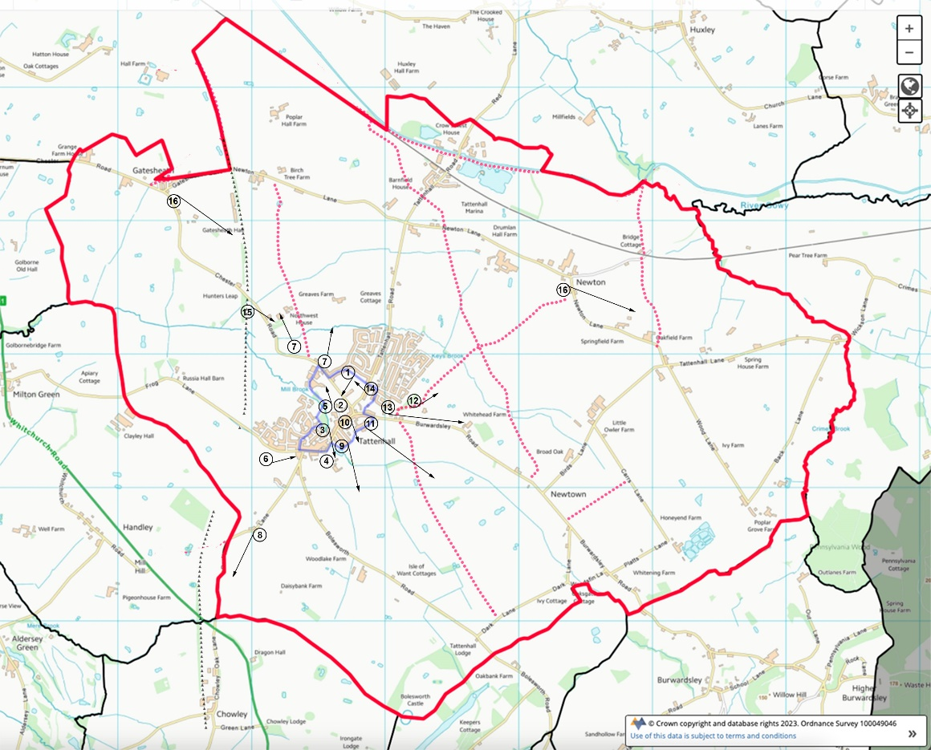
Views and Vistas
Millennium Mile.
Public Rights of Way
Disused Railway Line

Appendix B - Local Green Spaces

A. Sites of Open Space Value
Many of the estates in Tattenhall are built with grassed areas within them and at the entrances to them. These areas give the village its’ distinctive and characteristic open feel and promote a village rather than urban feel
a1. Land adjacent to Flacca Lodge, Burwardsley Road at entrance to Field Lane
Landowner: Cheshire West and Chester Council (CWaC)
Small area of open space, with footpath (Millennium Mile).
a2. Land within Covert Rise with willow trees
Landowner: CWaC
Small area of open space in housing estate.
a3. Land adjacent to Gorsefield – small area looking towards the Continuing Care Retirement Community
Landowner: CWaC
Small rectangle of open space adjacent to open fields.
a4. Land adjacent to the Spinney and Millbrook End
Landowner: CWaC
Area of open space adjacent to the Millennium Mile and the Mill Brook Wildlife Corridor Circular Trail. Bisected by footpath leading to Millbrook End. Clump of mature alders and adjacent to the Mill Brook.
a5. Land enclosed within the curtilage of Rean Meadow
Landowner: CWaC
Small area of open space within new housing estate.
a6. Land, with trees on the corner of Smithfields and Harding Avenue
Landowner: Your Housing
Small area of open space abutting Smithfields and Harding Avenue.
a7. Fenced land with trees adjacent to bungalow at the top of Harding Avenue
Landowner: CWaC
Small area of open space adjacent to sheltered housing at the top of Harding Avenue, containing, amongst others, a London Plane Tree. Views across farmland and towards Beeston Castle.
a8. Land on right hand side of Park Avenue backing onto Rean Meadow
Landowner: CWaC
Small triangular area of open space. View into surrounding field.
a9. Land around junction of Keysbrook and Keysbrook Avenue (3 sides of road)
Landowner: CWaC; Chester & District Housing Trust
Small area of open space.
a10. Land at entrance to Millbrook Park estate
Landowner: CWaC
Small area of open space.
a11. Land at entrance to Newall/Breen Close Landowner: Cawood Homes
Very small triangle of land adjacent to the High Street and Mill Brook.
a12. Open spaces within Oaklands, Greenlands, Rookery Drive areas
Landowner: CWaC
Various areas of open space in large housing estate.
a13. Land within Curtilage of Grakle Croft properties
Landowner: Your Housing
Small area of open space in front and to rear of fourteen new affordable homes.
a14. Land at entrance to, and along, Ravensholme Lane
Landowner: Chester & District Housing Trust
Small area of open space. Interpretation panel for the Mill Brook Wildlife Corridor to be located here.
a15. Land on Castlefields
Landowner: CWaC
Small areas of open space.
B. Sites of Sport, Recreation and Amenity Value
These are sites valued for their open access for Sport, Recreation and Amenity. They are areas were residents can come together both informally and where community events are held
b1. Castlefields play area
Landowner: CWaC
Play area for local children.
b2. The Park playing field
Landowner: CWaC
Large playing field used by the Park Primary School and the local community. Seasonal football pitch and marked lanes for school sports day. Play area for local children. Mature trees and public footpath.
b3. Sport Tattenhall playing fields
Landowner: Bolesworth Estate
Football and cricket pitches, tennis courts and new croquet lawn. Local community resource but hosting occasional county sporting events (Minor Counties cricket).
b4. Allotments on Rocky Lane and at Gatesheath
Landowner: Bolesworth Estate; Tattenhall & District Parish Council
Allotments used by the local community.
C. Sites of Nature Conservation Value
c1. The Mill Brook Wildlife Corridor
Landowners: Riparian ownership includes Bolesworth Estate, Tattenhall and District Parish Council, CWaC, private individuals
Managed by: Tattenhall Wildlife Group
Funded by: EU Leader Programme
Wildlife corridors maintain viable populations that would otherwise suffer as a result of habitat fragmentation and isolation and, as a result, are extremely diverse. The Mill Brook is a significant wildlife corridor which links isolated habitats such as woodland and grassland, allowing species to disperse throughout the area. As a linear habitat, it is also important in the dispersal of seeds and in attracting insects for pollination. As the Mill Brook passes through the village of Tattenhall, much of this corridor is accessible to the local community and a new permissive footpath through Jubilee Wood provides an important link with other footpaths in the locality.
Financial support from the Leader Programme has seen the production of two interpretation panels, a circular trail leaflet and the Tattenhall Wildlife Group website. Practical conservation work supported includes pond and scrape creation, restoration of 200 metres of disused railway line (see below), wildflower planting, tree planting.
c2. Jubilee Wood
Landowner: Bolesworth Estate
Managed by: Tattenhall Wildlife Group
Funded by: EU Leader Programme, Woodland Trust, Bolesworth Estate and CWaC.
Located on the Mill Brook Wildlife Corridor
Community woodland of 1,500 trees planted to celebrate the Queen’s Diamond Jubilee, 2012. Wood in three compartments comprising a hazel coppice and over 14 Cheshire native species planted within 1.5 hectares. The third compartment is an area of old woodland with distinctive ground flora including native bluebells which were planted in 2012. Leader money has been used to create five ponds, restore one pond and plant woodland wildflowers. Permissive footpath through the Wood used by the local community and connects with public right of way. Site qualifies as a Local Wildlife Site with over 20 species of butterfly recorded.
c3. Glebe Meadow
Landowner: Tattenhall & District Parish Council
Funded by EU Leader Plus programme (2006)
Located on the Mill Brook Wildlife Corridor
Local Wildlife Site (LWS). Small area (2 hectares) of unimproved grassland in which over 23 species of grass have been recorded. Rare breed cattle from Cheshire Wildlife Trust graze the meadow during the summer months.
c4. Barn Field (land behind flats at Ravensholme Court)
Landowner: Tattenhall & District Parish Council
Located on the Mill Brook Wildlife Corridor
Barn Field is an area of unimproved grassland which is now being restored and managed as a wildflower meadow. Lying adjacent to Mill Brook, it is an integral part of the corridor and is a valuable habitat for wildlife. Surrounding trees provide suitable nesting sites for songbirds and, during the summer months, hoverflies, bees and other insects can be identified. Peacock, small skipper and small tortoiseshell butterflies are common here. Several species of bat also roost in this area. Botanical survey scheduled for 2013. Support for the field from residents of Ravensholme Court sheltered housing. Mill Brook Wildlife Corridor interpretation panel installed 2013.
c5. Land bounded by Barn Field, Glebe Meadow and the Spinney
Landowner: CWaC
Managed by: Tattenhall & District Parish Council
Located on the Mill Brook Wildlife Corridor
Adjacent to the Mill Brook this is an area of land managed for nature conservation. Lies along the Mill Brook Wildlife Corridor Circular Trail and the Millennium Mile.
c6. The Spinney – an area of woodland that runs behind the High Street
Landowner: Tattenhall & District Parish Council
Located on the Mill Brook Wildlife Corridor
An area of mature woodland in the heart of the village. Originally planted as a willow coppice in the first decade of the 20th century, the timber has never been harvested. Mature trees and significant ground flora including bluebells, wood anemones, ramsons, celandine. Large rookery supports up to twenty-five nests, tawny owls and great spotted woodpeckers present. Excellent invertebrate structure in dead and decaying timber. Adjacent to the Mill Brook
c7. Mill Field
Landowner: Bolesworth Estate
Managed by: Tattenhall Community Association and Tattenhall Wildlife Group
Located on the Mill Brook Wildlife Corridor
Small field in the heart of the village and bisected by the Millennium Mile and Mill Brook Wildlife Corridor trail. Currently under restoration as a flowering natural and semi-natural meadow. Seats and interpretation panel in a small landscaped circle.
c8. Disused railway line between Chester Road and Frog Lane
Landowner: Bolesworth Estate
Managed by: Tattenhall Wildlife Group
Funded by: EU Leader Programme
Located on the Mill Brook Wildlife Corridor
Recently restored by Tattenhall Wildlife Group the disused railway line provides a significant terrestrial corridor crossing the Golborne Brook. Providing views into Tattenhall, the Sandstone Ridge and the Welsh Hills. Part of the line is a Local Wildlife Site due to the presence of common spotted orchids. Floristically diverse corridor extending for 200 metres.
c9. Entrance to and field in front of Tattenhall Hall
Landowner: Private ownership
Located on the Mill Brook Wildlife Corridor
Significant wildflower meadow at the front of Tattenhall Hall.
c10. Allotment Pond, Rocky Lane
Landowner: Bolesworth Estate
Large marl pit surrounded by mature oaks adjacent to the allotments off Rocky Lane. Ongoing management work including tree removal and hedge laying.
c11. Land Within Curtilage of Tattenhall Marina
Landowner: Bolesworth Estate
A significant area of land surrounding three sides of the Marina has been developed for nature conservation and includes a series of ponds, wildflower meadow and planting of native trees. In addition, a new permissive footpath links the Canal with Newton Lane.”

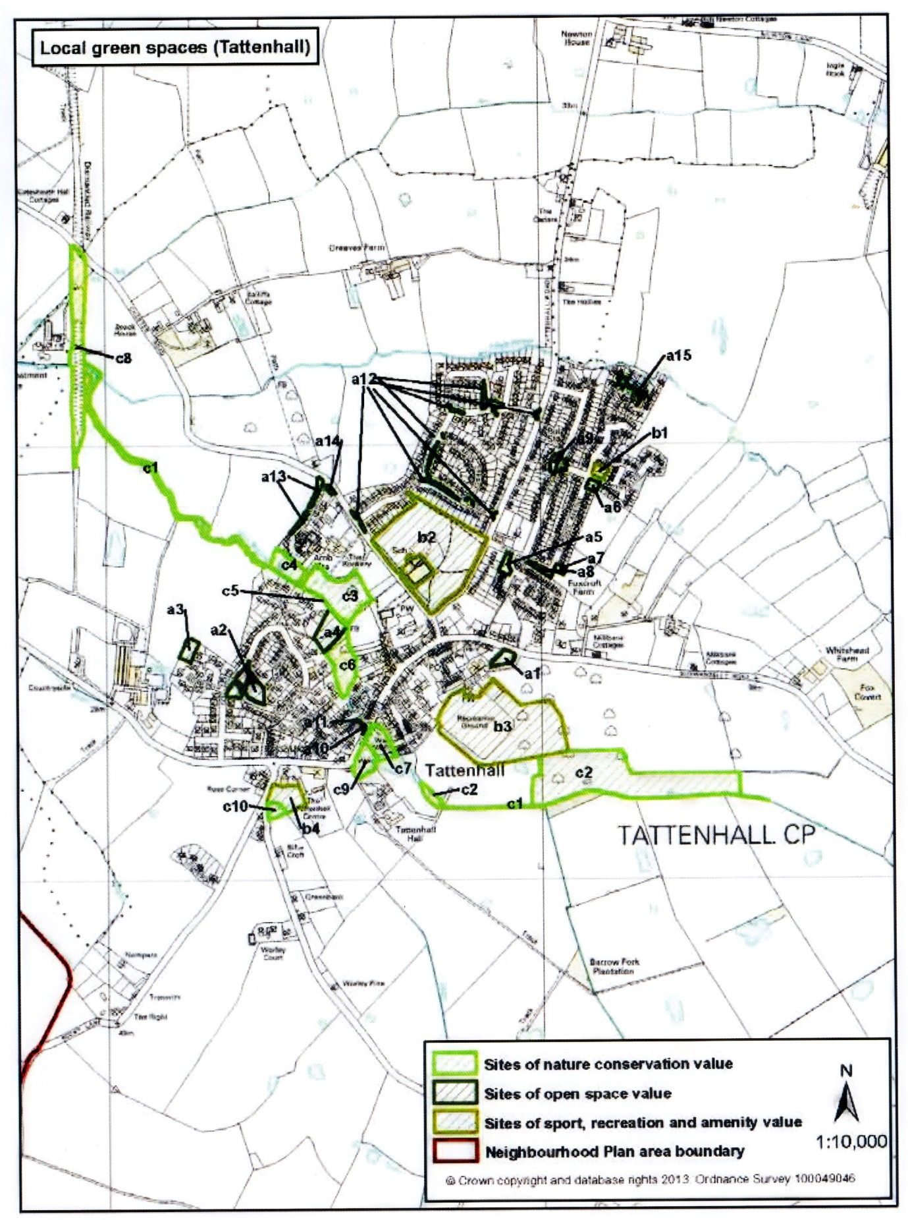

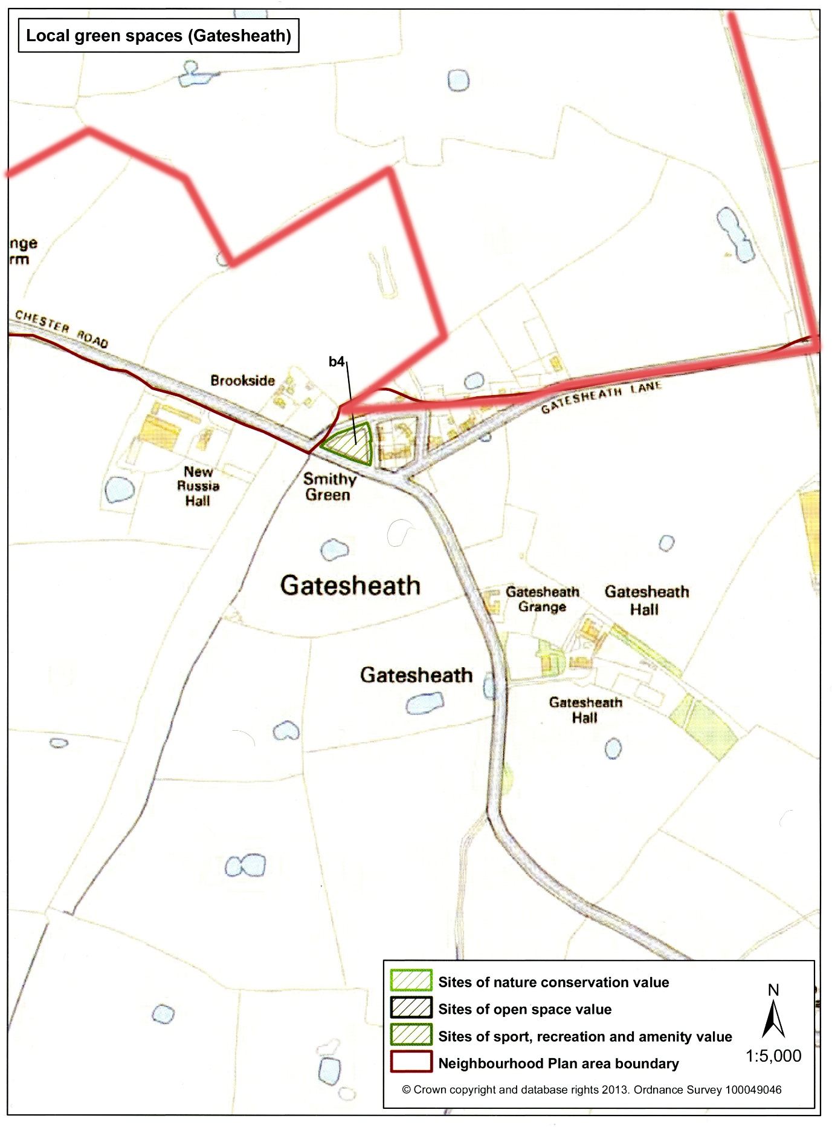

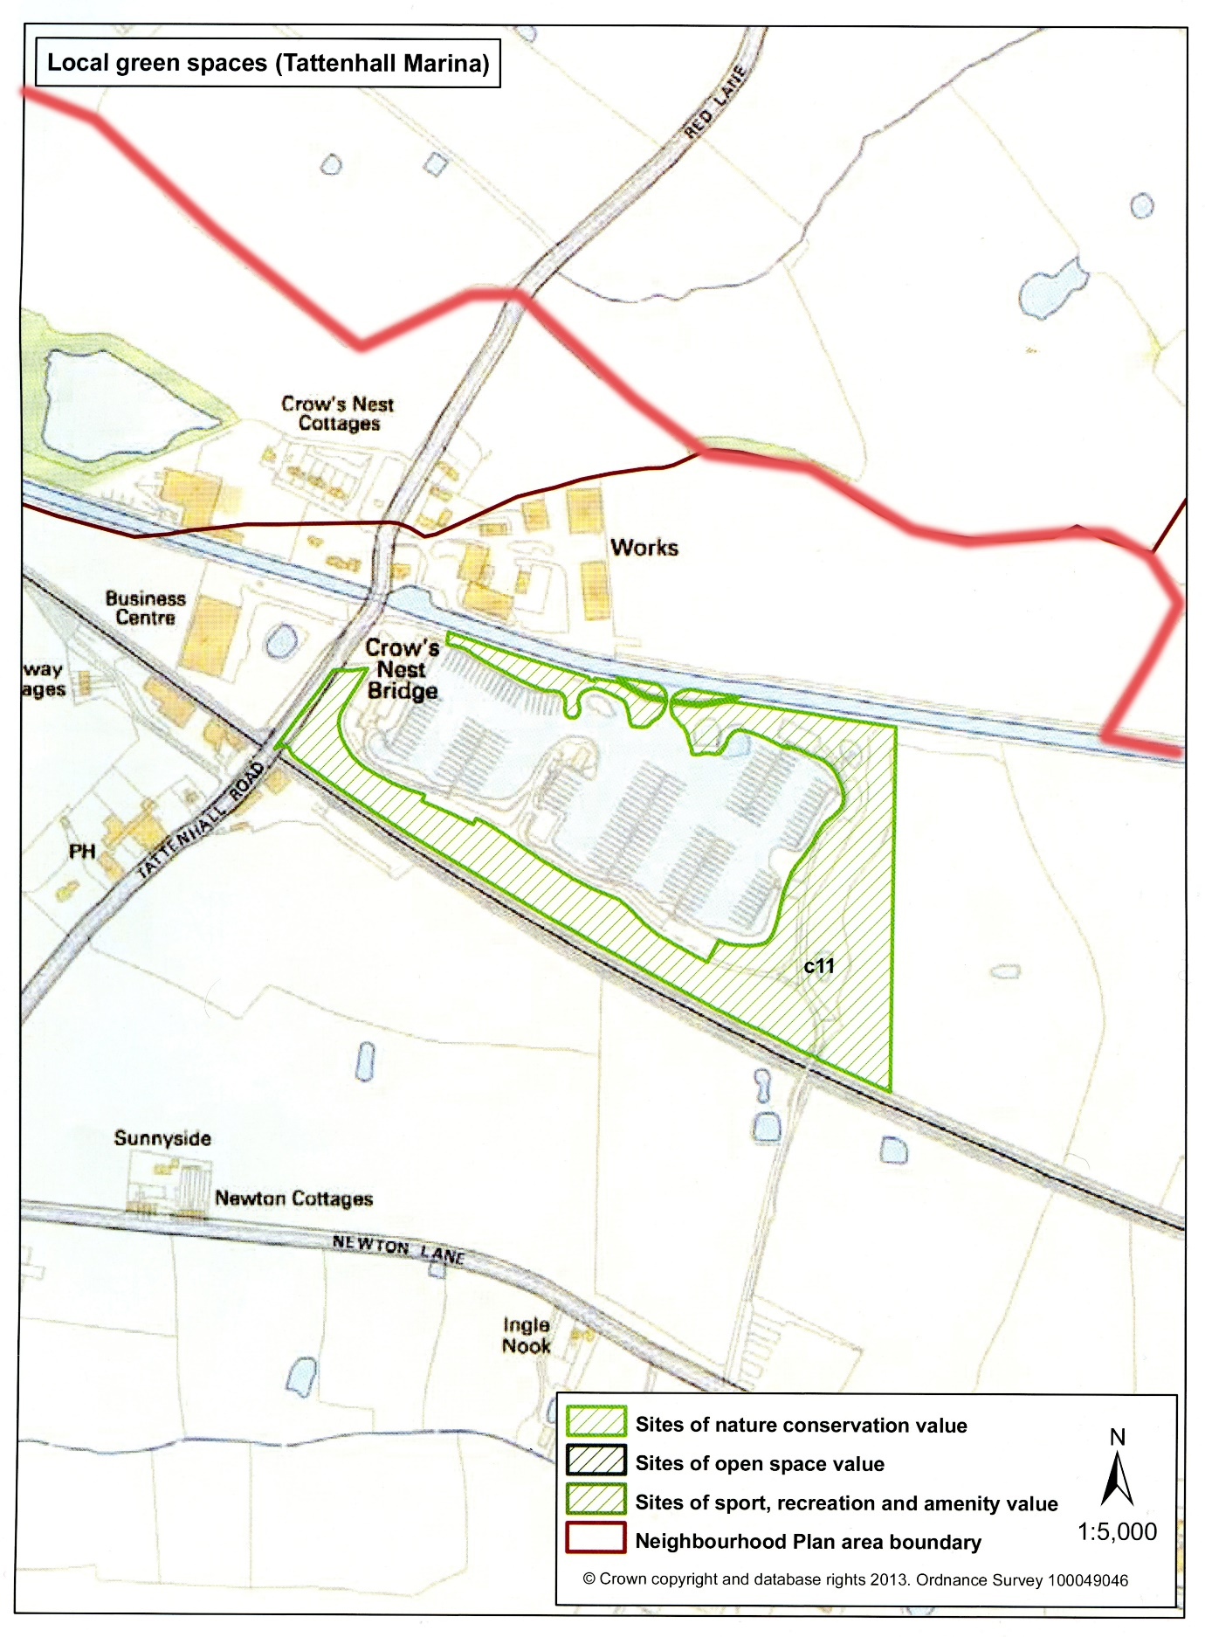

http://www.bailii.org/ew/cases/EWHC/Admin/2014/1470.html
https://cheshirewestandchester.objective.co.uk/portal/cwc_ldf/adopted_cwac_lp/parttwo_adopted?pointId=s1561545628433#section-s1561545628433
https://pa.cheshirewestandchester.gov.uk/online-applications/search.do?action=advanced&searchType=Application
http://tattenhallpc.co.uk/wp-content/uploads/2023/12/Tattenhall_NP_Design-Code_2023.pdf
https://www.ons.gov.uk/datasets/TS044/editions/2021/versions/4/filter-outputs/573c0c8c-0bb3-44e0-9e14-f95b6863b33a
http://tattenhallpc.co.uk/wp-content/uploads/2024/03/Tattenhall-HNA-Report-FINAL-VERSION.pdf
http://tattenhallpc.co.uk/wp-content/uploads/2024/03/Tattenhall-HN-Report-DRAFT-V1-2023.pdf

